

Tools 🡪Extention and Updates 🡪Online

* Productivity power tools
* Web essential

Then close visual Studio and open it again

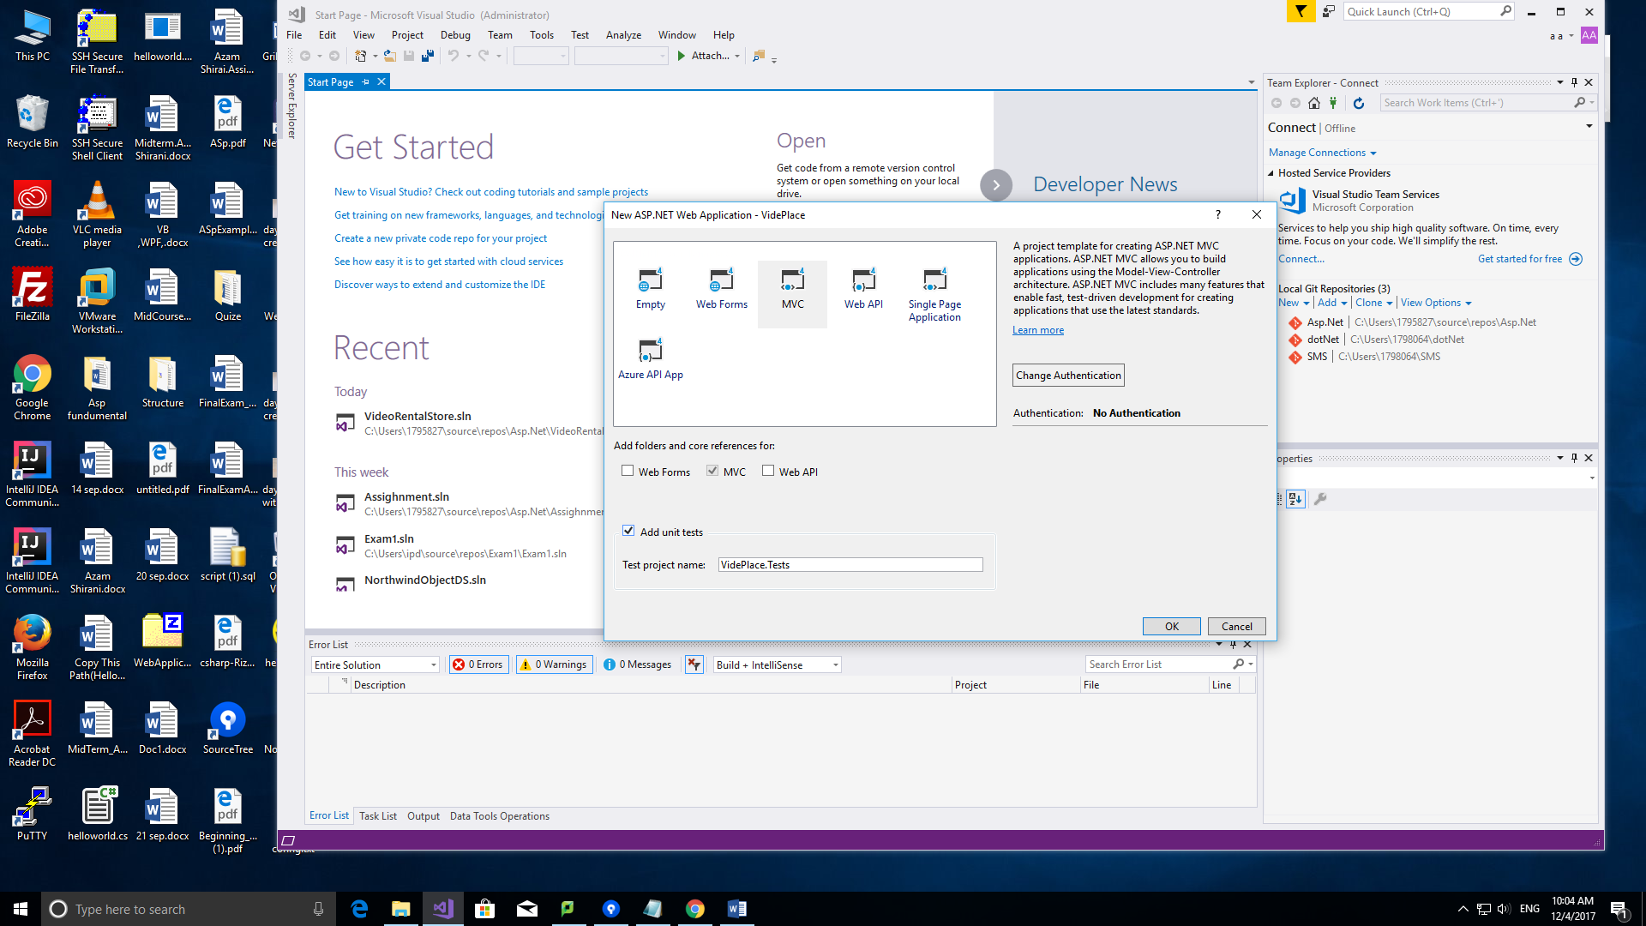

App_Data=SQl

App_Start=C# class

Content= How to Design your website like bootsrutarp

Controllers: I have matching a folder match to each one like account folder ,Home and Manage

Account:

Home:

Manage:

Font=

Script= JavaScript

View=Folders each folders include a file name

Package config:

Global.

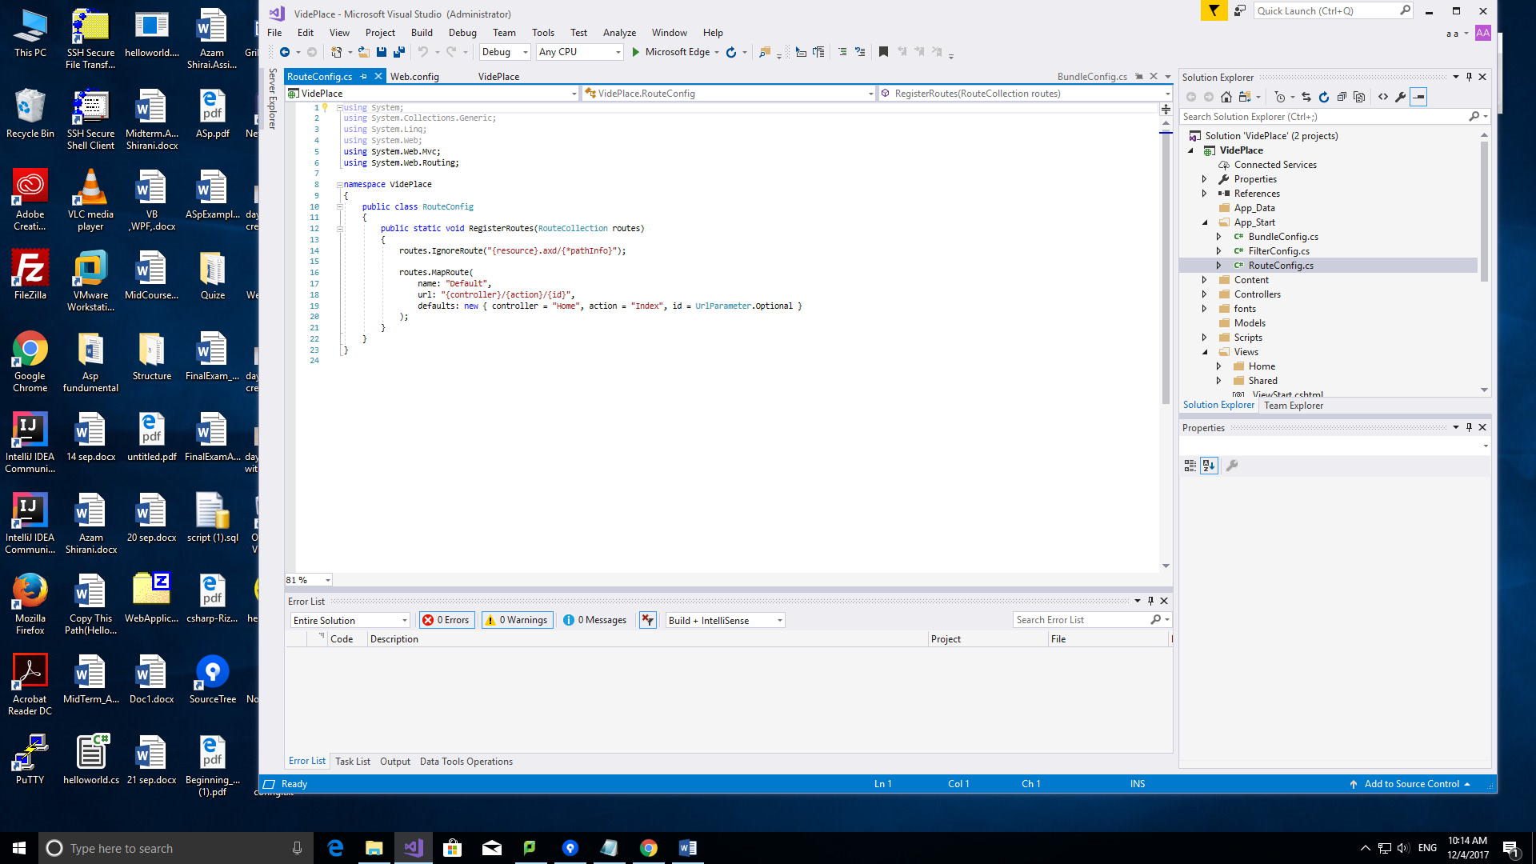

This function: Read item by item

This is a default one.

Under controller has different actions id is an optional parameter.

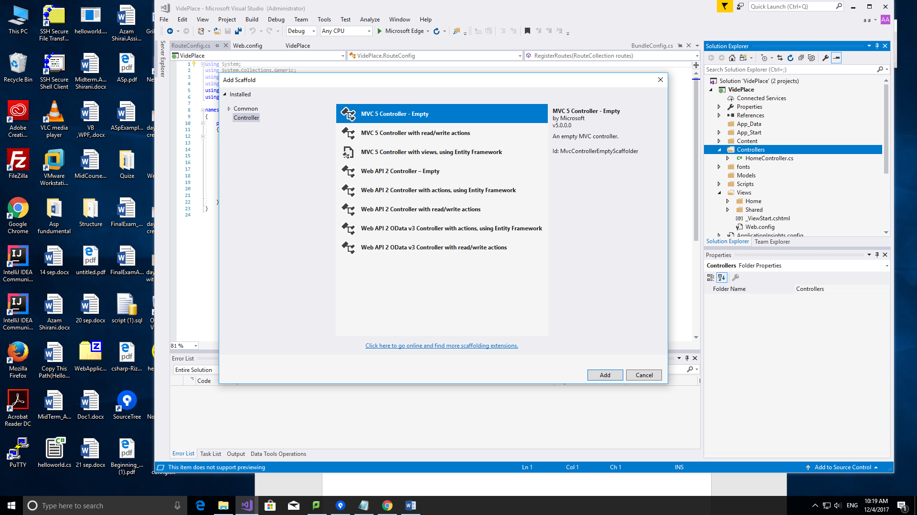

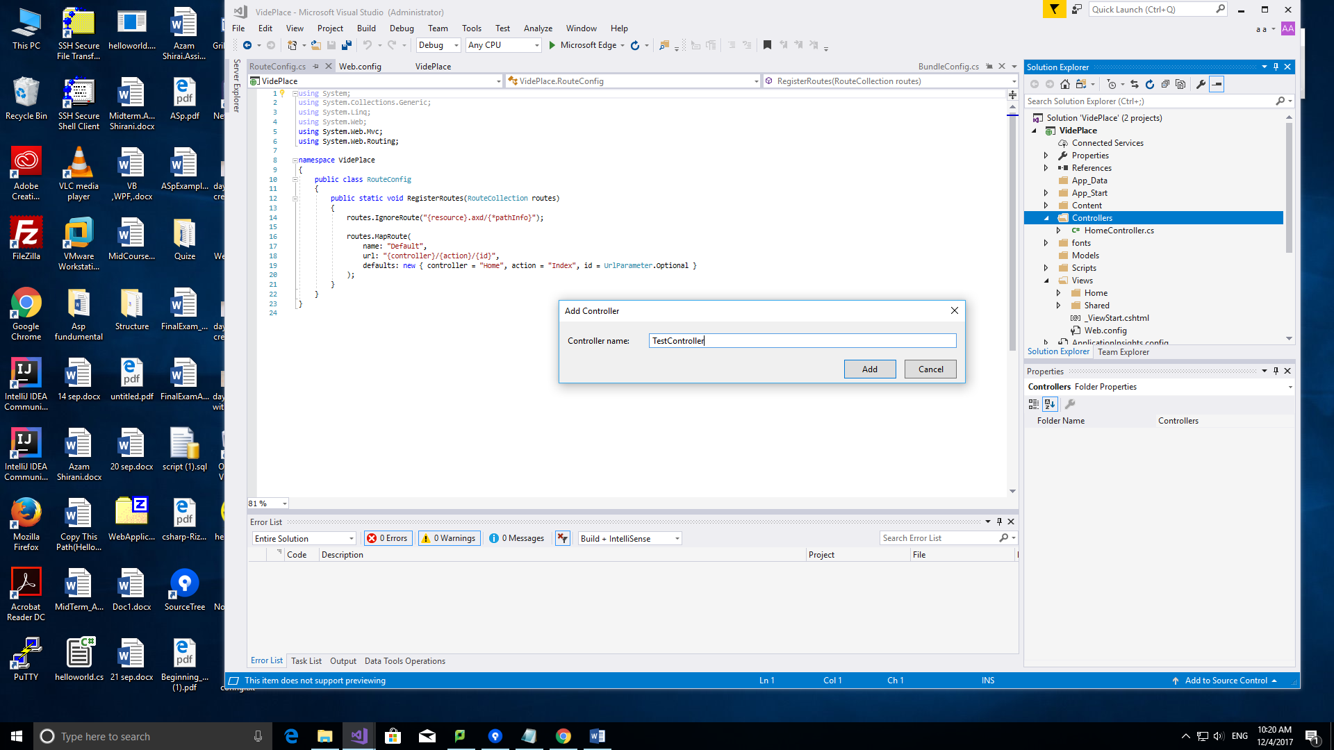

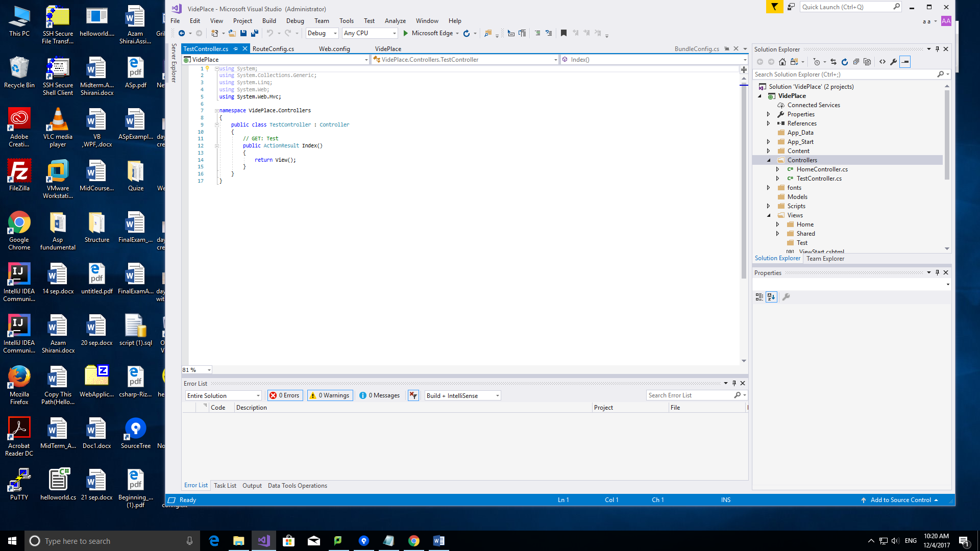

In TestCon

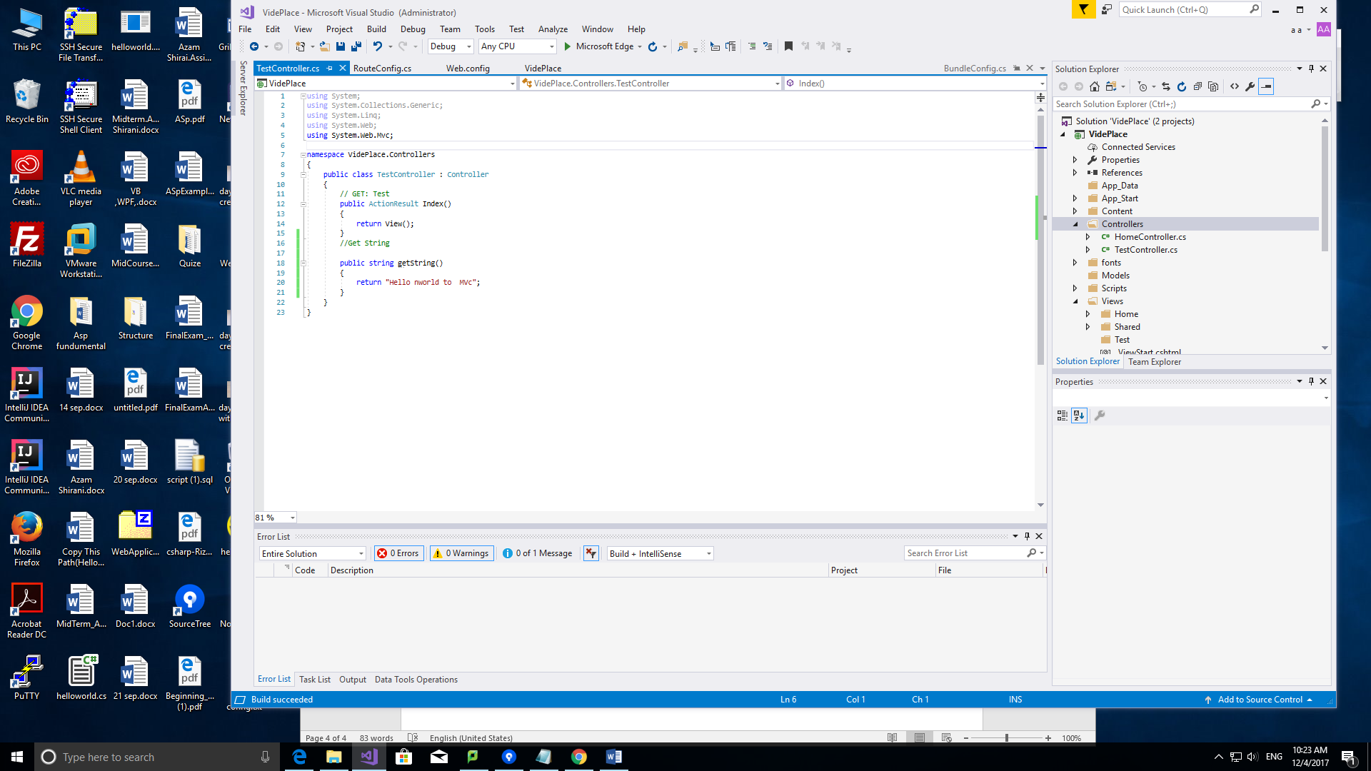

Press cCTRL+F5



We can change the default

Home=test

Action=get String

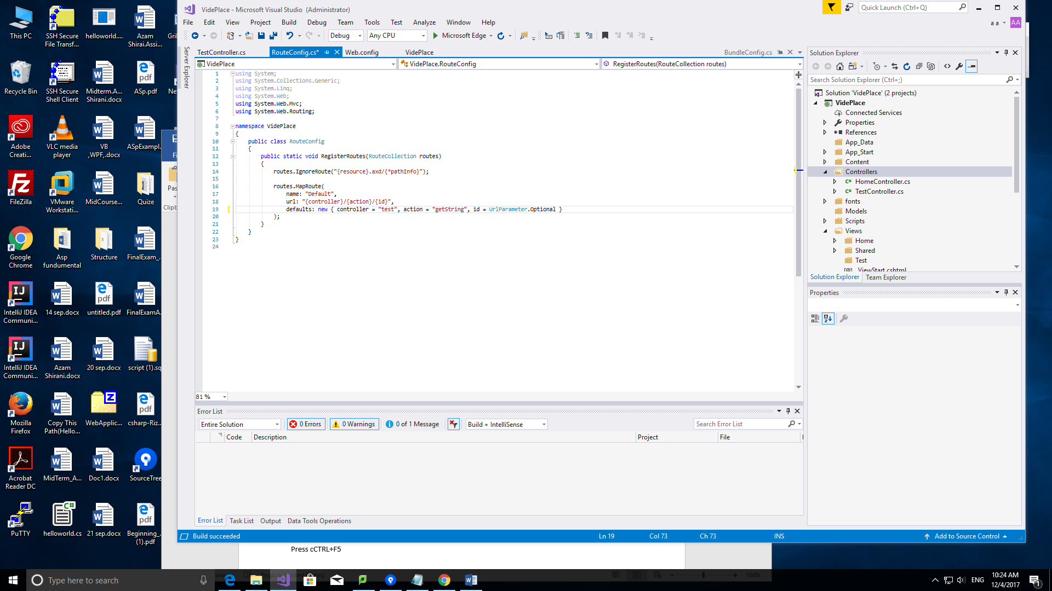

We can add as many as want, it runs orderly

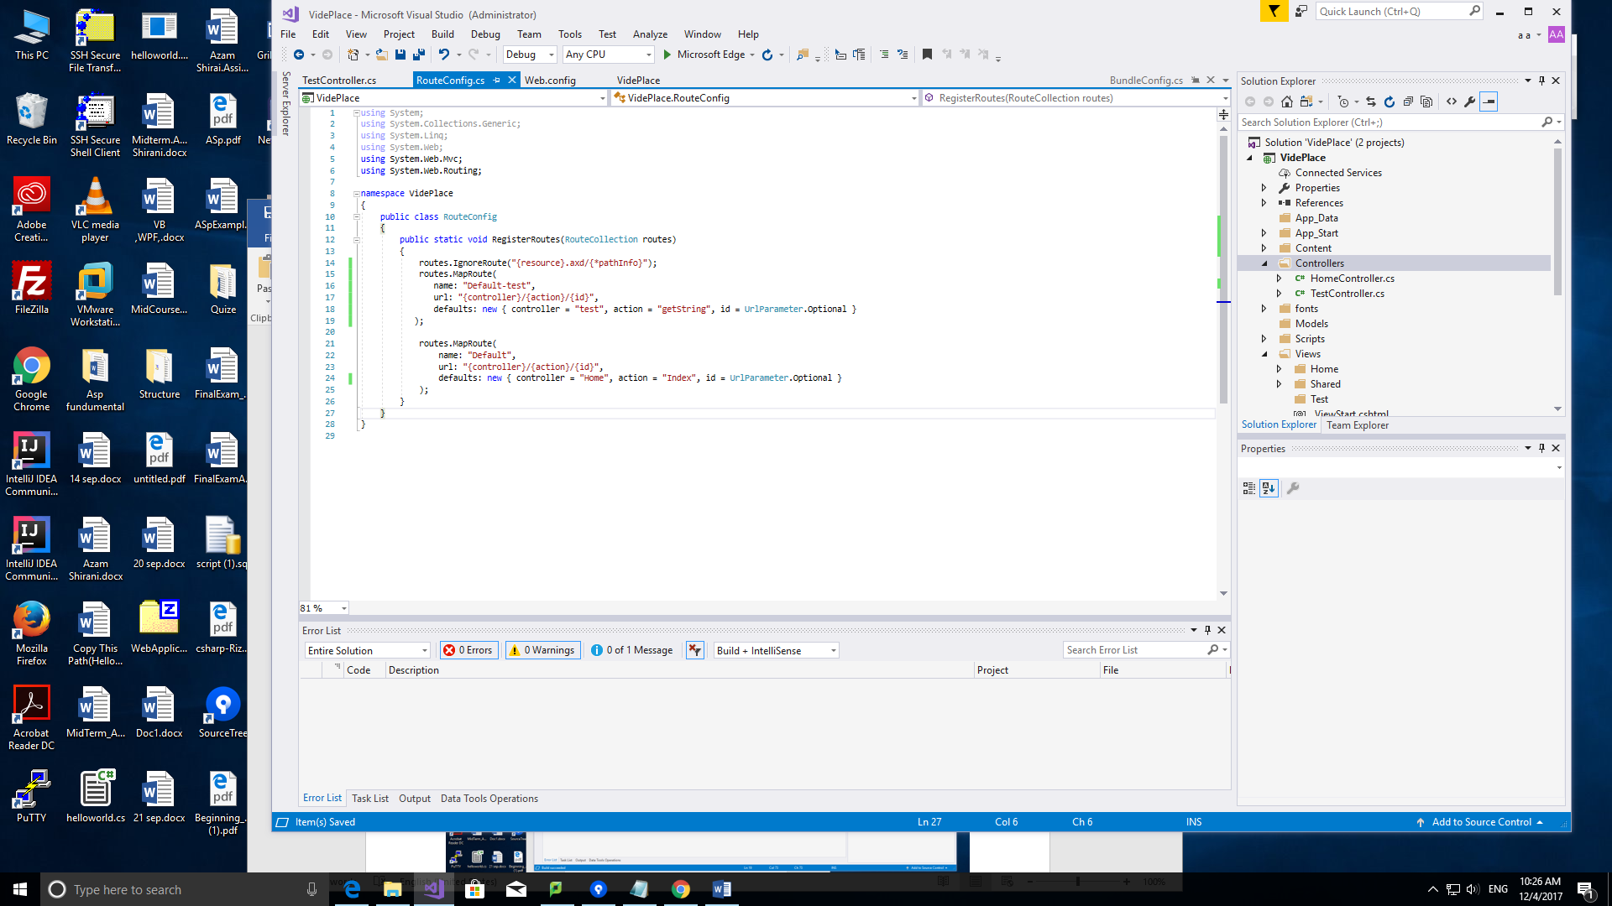

Then it automatically runs as first one



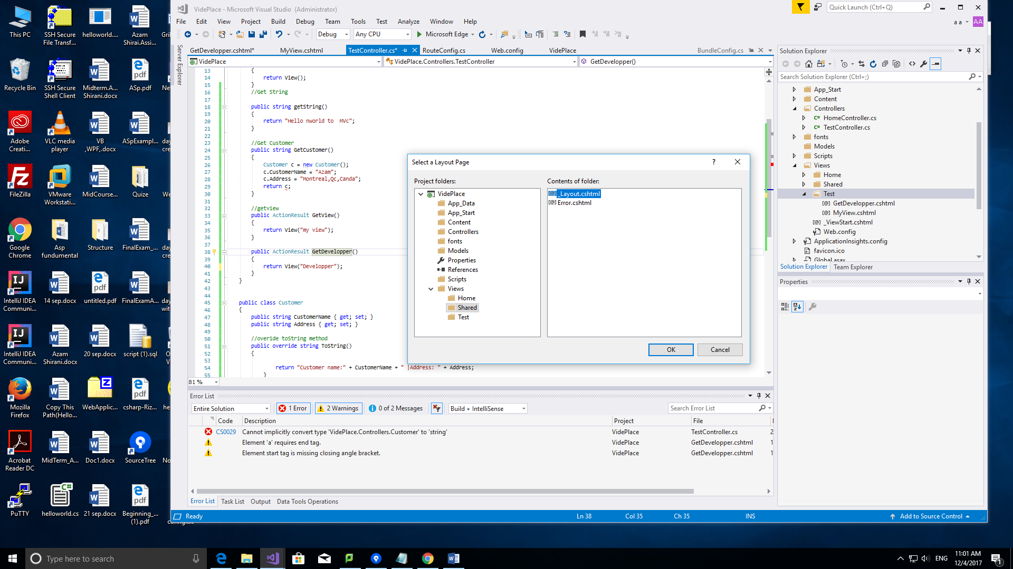

The name of view in test folder must be match



Not the name of method but the name of return view(“…”)





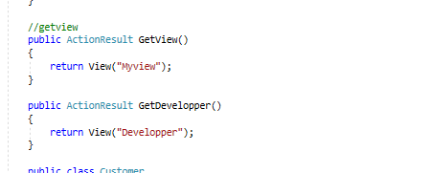

Each Controller has the same view

Path name of the view is different so there is no collision

Note:PROP dokmeh tab tab

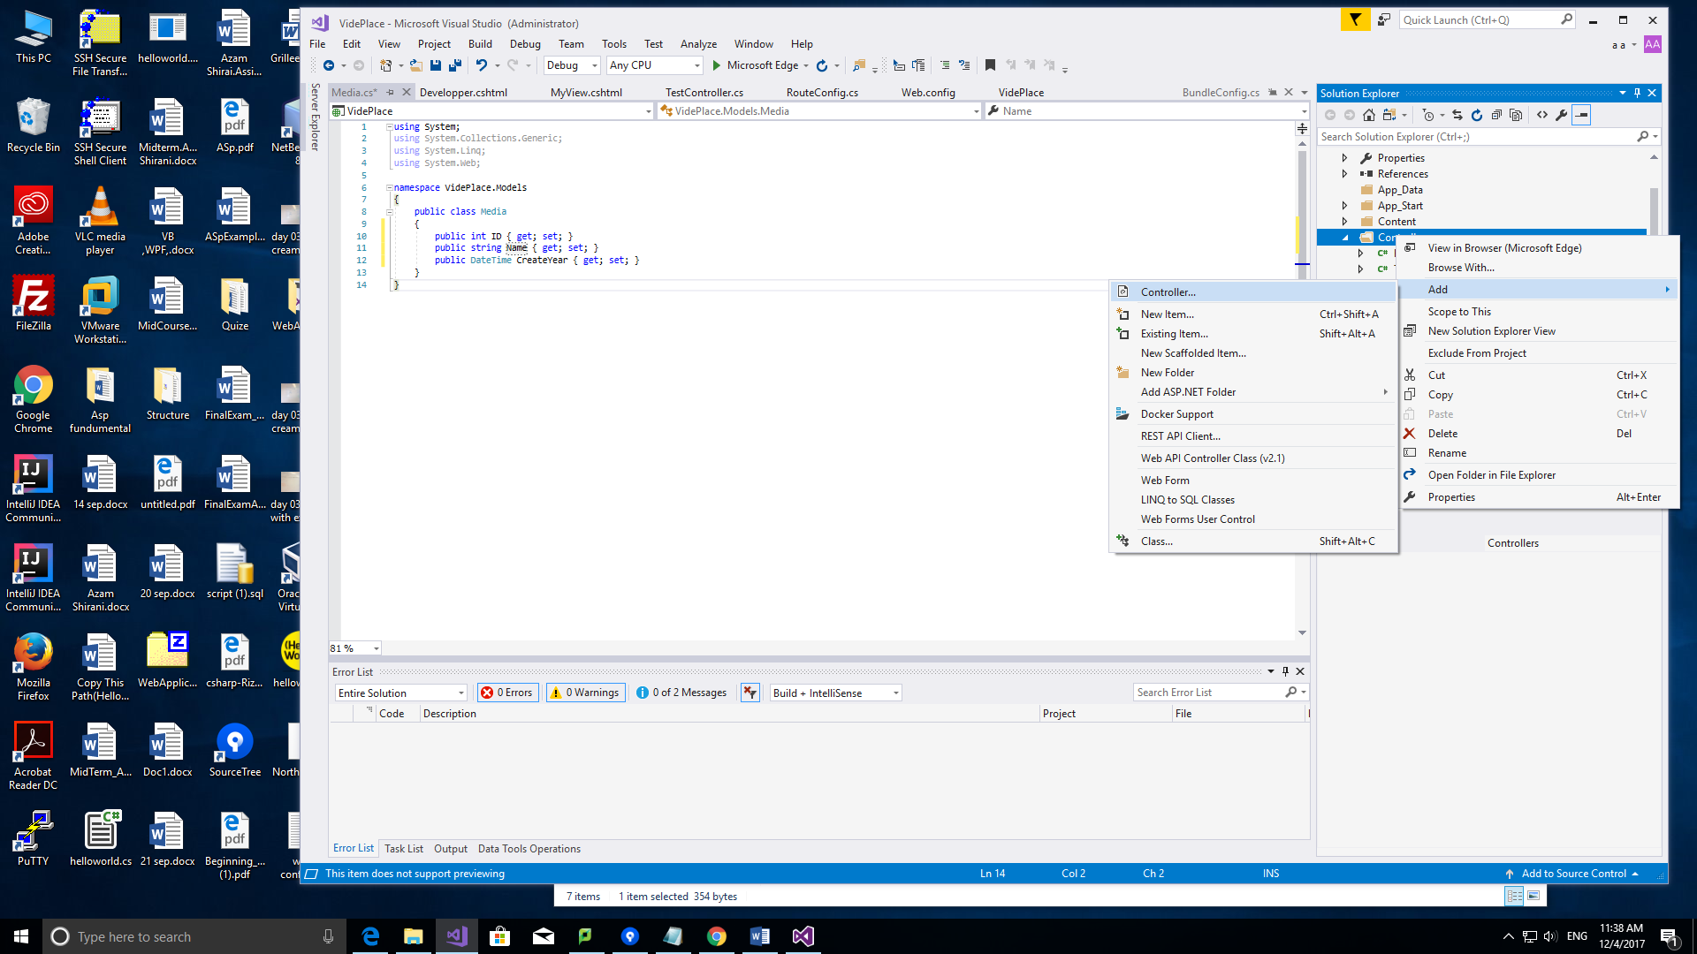

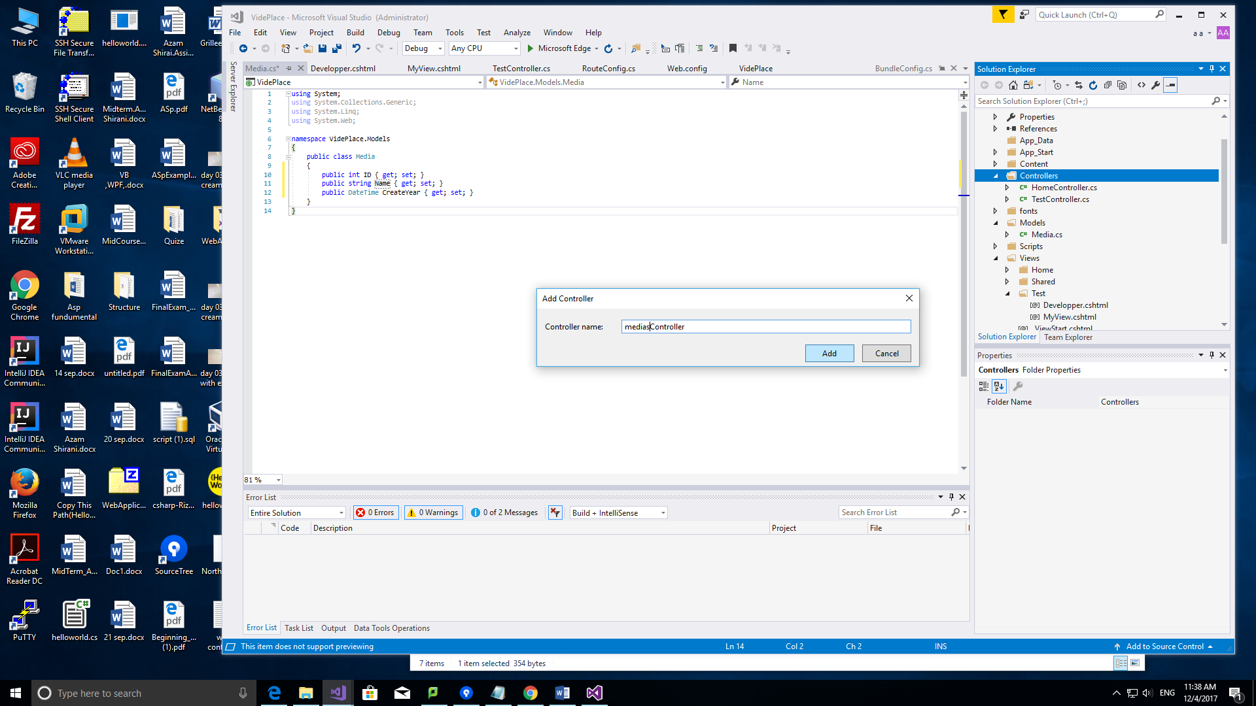



Add



Moodle🡪add controller

<https://bootswatch.com/>

gives the header…

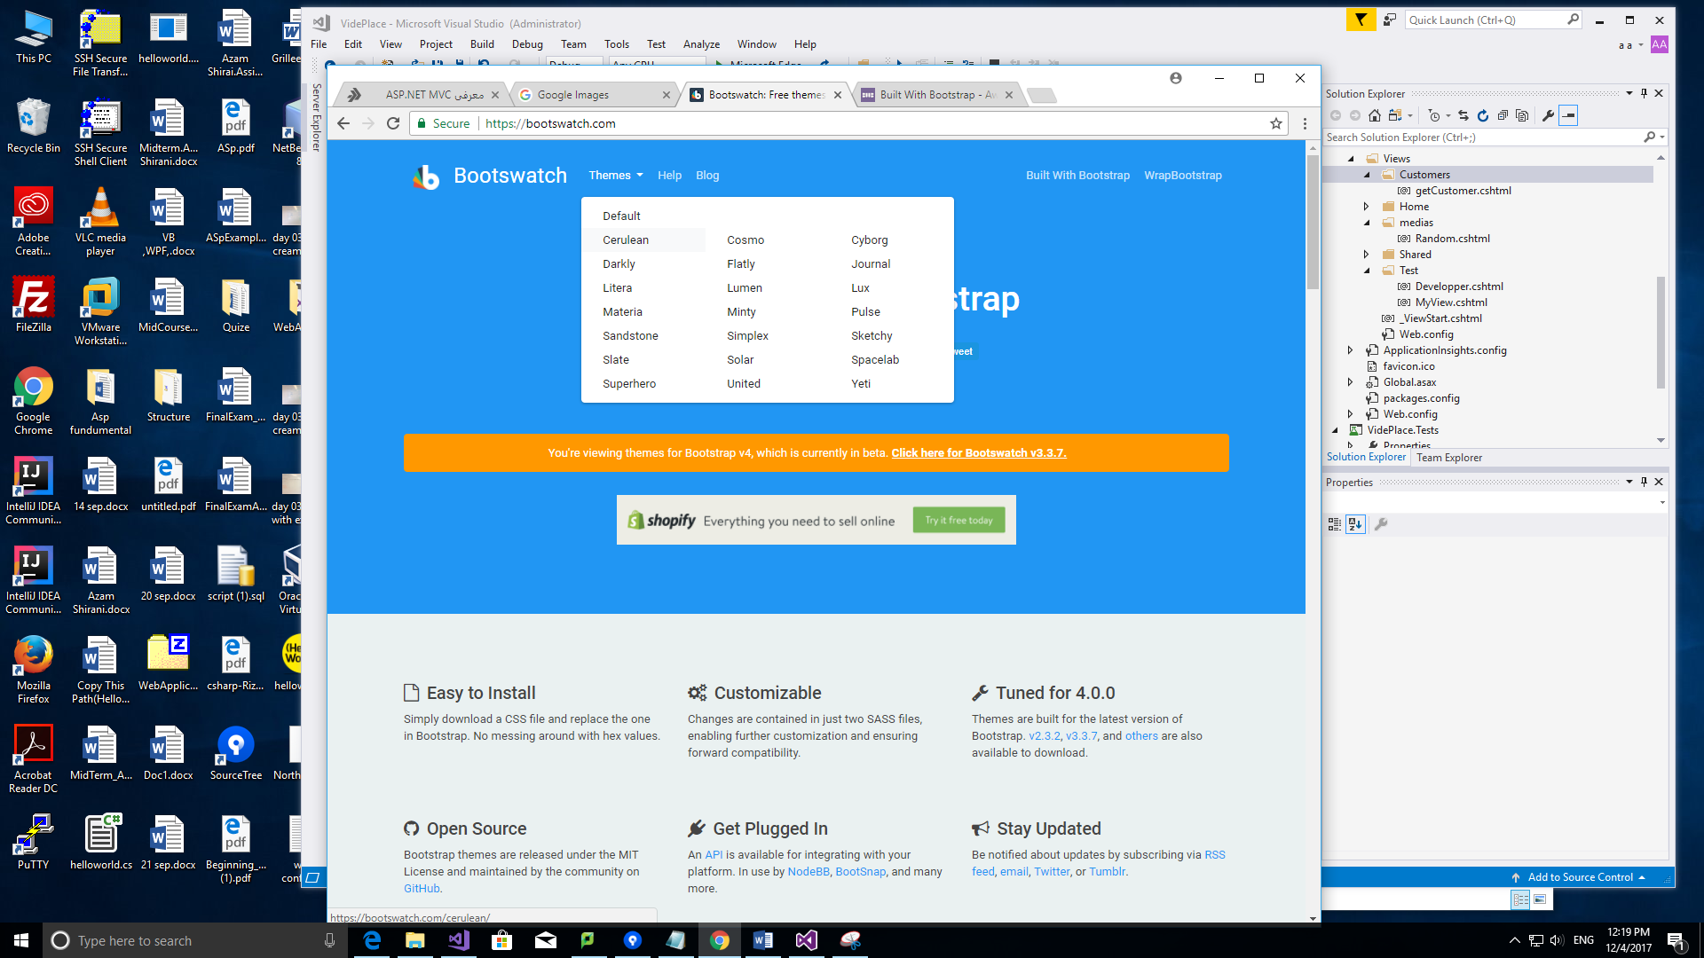

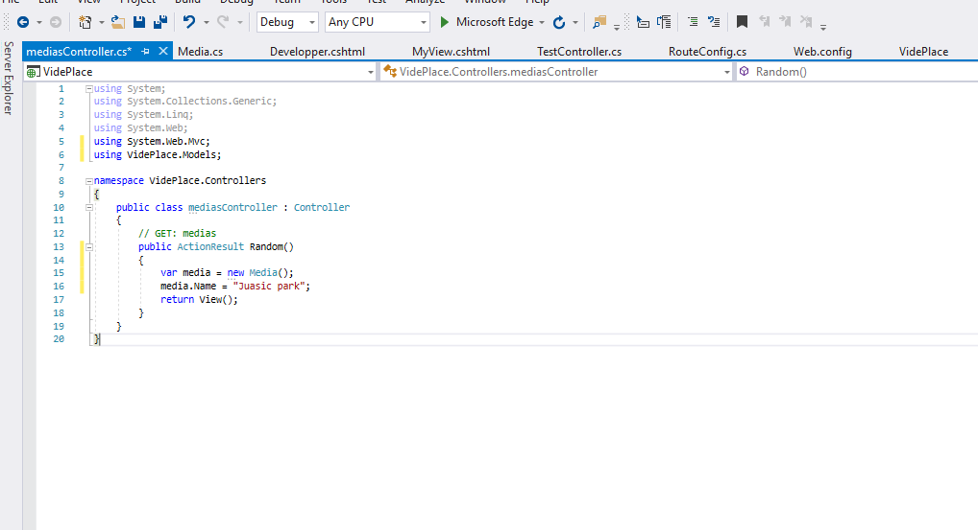

Create a view

Then I need to access media (object of this method)

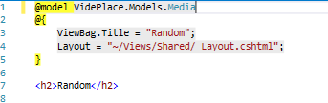

Access the properties of this object:



Pass object here:





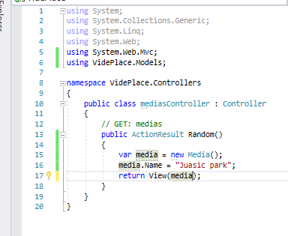

Run in View

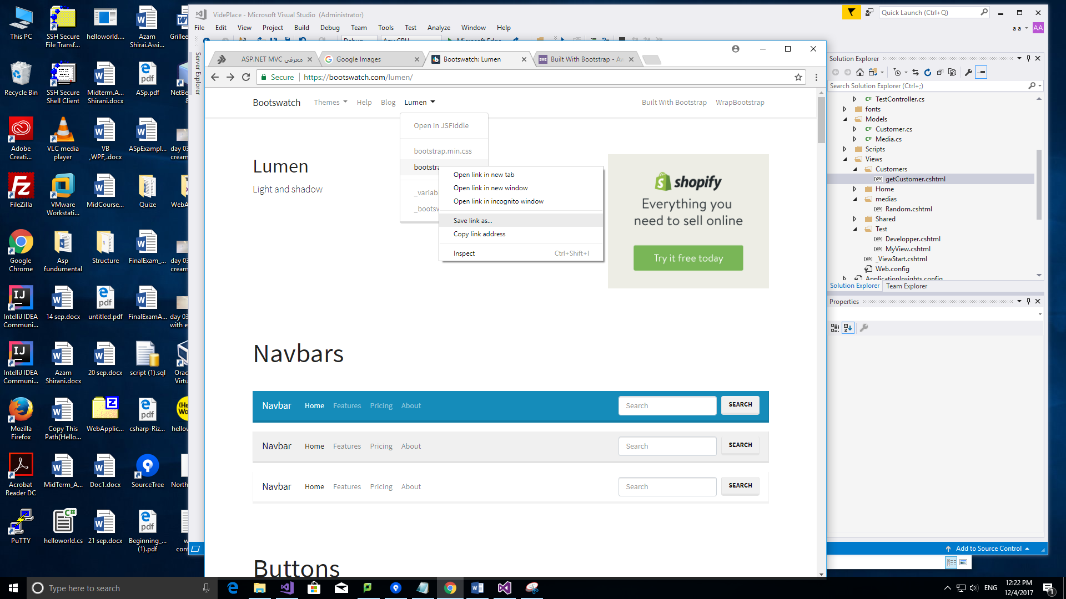

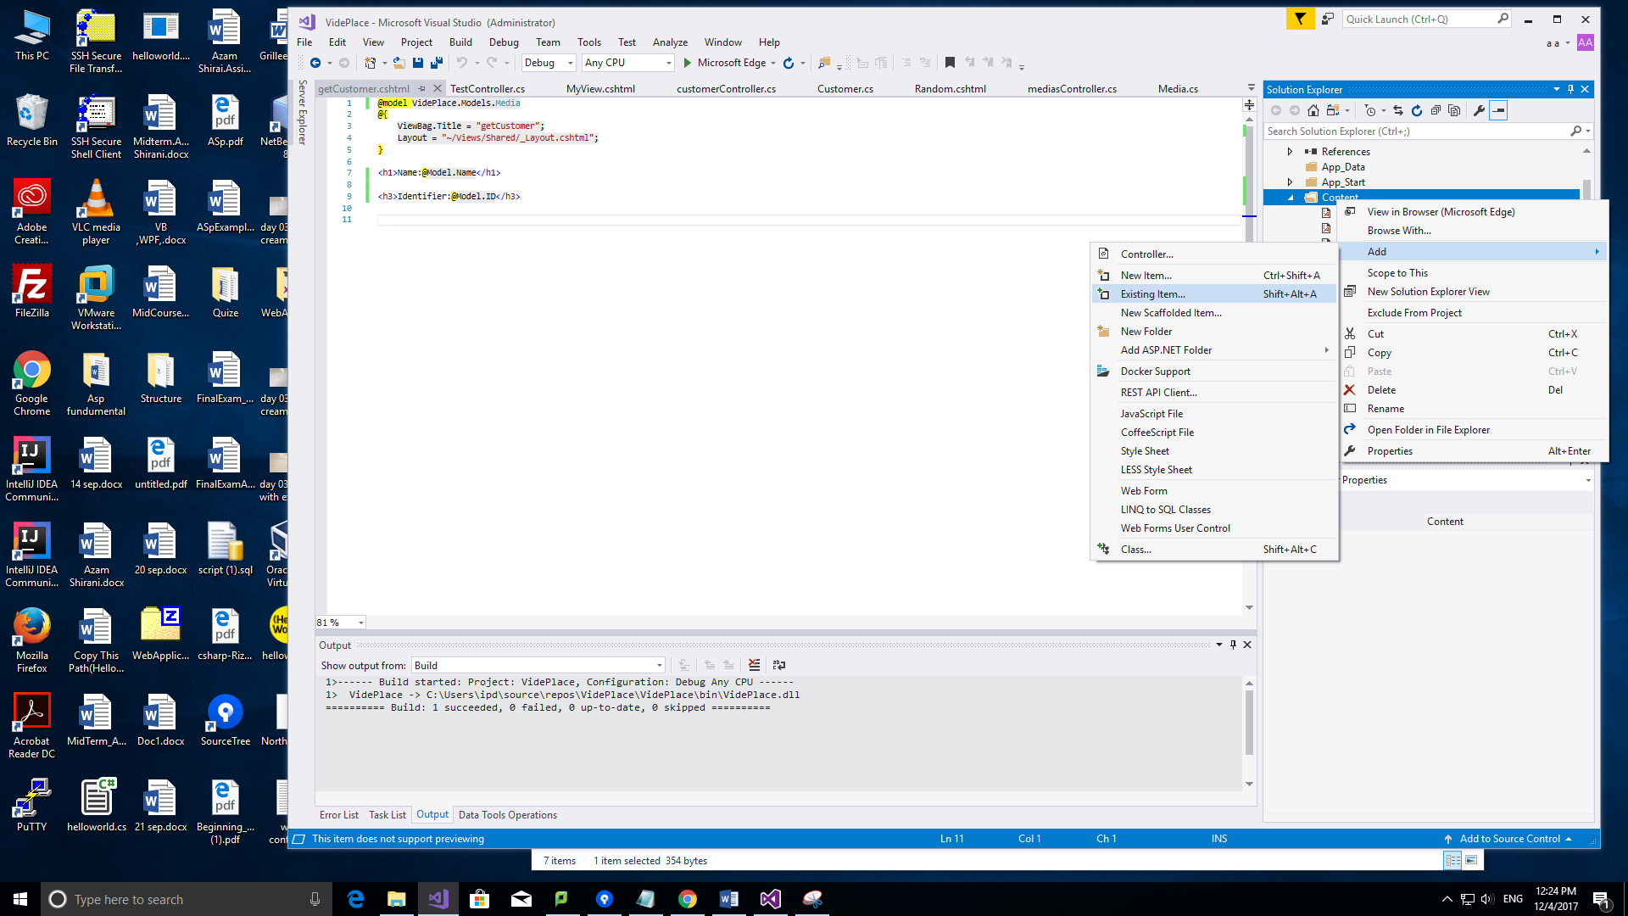



Bundle: It checks all folder and analyses web sites, allow u load them with one request

Change the name of css:



How to understand dis query string: Query String 🡪?-->

Note: Anonymous object: is an object with no class

Action: need to have input/from url or query string/

URL Path:

/ Controller/action/Parameter

/media/edit/100

2ned parameter: method= /media/edit/?id=100 it needs pair

There is two methods to access url

1. Inside url
2. Query string

Must change in bundle id

Route Config: change: media-index

url:medias/index/{pageindex}/{sortBy}

//primitive type: to solve the problem: Create default Value with Question mark

change in 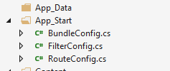

/10/Date

Medias/index?pageIndex=10 in query string it passes true

Media/username?last=Tom

Non-nulable

Int is not an object it can’t be null line =38 (primitive Data Type)

For object it considers a pace

Sort by=

Index page=10 line